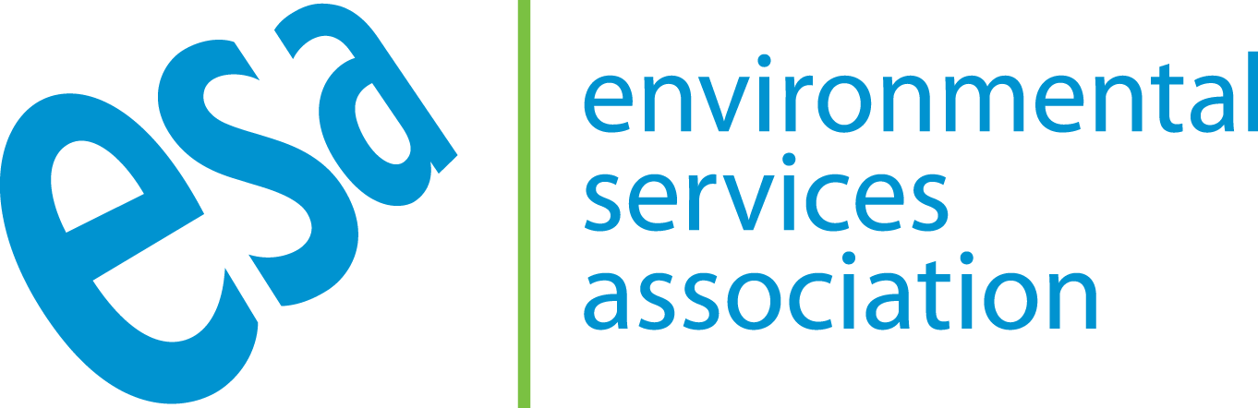

Media release

ESA WELCOME EPR & DRS CONSULTATIONS BUT QUESTION WHY CONSISTENCY HAS BEEN DELAYED

24 March 2021

The Environmental Services Association (ESA) has responded to the recent publication by Defra of their consultations in DRS and EPR.

Executive Director of the Environmental Services Association (ESA), Jacob Hayler, said: “We welcome today’s important progress milestone for Defra’s Resources and Waste Strategy and we look forward to reviewing and responding to these critical consultations in detail alongside our members. Fundamentally, the long-term success of these policies will be determined by their ability to make it easier for consumers to recycle properly; to incentivise producers to make things more recyclable; and to underpin investment by our sector in the next generation of new UK recycling infrastructure, so it is through these lenses that we will be considering our responses.

The complex policy interventions set out in these consultations must be considered holistically rather than in isolation, so the decision to consult separately at a later date on collection consistency does raise some immediate questions about whether stakeholders will be able to properly assess how the proposed measures will work together in a systemic way, but we remain hopeful that the full picture will become clearer well before the end of the consultation period.

ENDS

Notes to editors:

The Environmental Services Association (ESA) is the voice of the recycling and waste management sector in the UK. You can find out more about our work and our members in our Annual Report available from www.esauk.org

A summary of the fly-tipping statistics is included below:

- For the 2019/20 year, local authorities in England dealt with just under 1 million (976,000) fly-tipping incidents, an increase of 2% from the 957,000 reported in 2018/19.
- Just under two thirds (65%) of fly-tips involved household waste. Total incidents involving household waste were 632,000 in 2019/20, an increase of 7% from 588,000 in 2018/19.
- The most common place for fly-tipping to occur was on highways (pavements and roads), which accounted for over two fifths (43%) of total incidents in 2019/20. In 2019/20, the number of highway incidents was 419,000, which was an increase of 6% from 396,000 in 2018/19.
- The most common size category for fly-tipping incidents in 2019/20 was equivalent to a ‘small van load’ (34% of total incidents), followed by the equivalent of a ‘car boot or less’ (28%).
- In 2019/20, 33,000 or 3% of total incidents were of ‘tipper lorry load’ size or larger, which is a decrease of 8% from 36,000 in 2018/19. For these large fly-tipping incidents, the cost of clearance to local authorities in England in 2019/20 was £10.9 million, compared with £12.8 million in 2018/19.
- Local authorities carried out 474,000 enforcement actions in 2019/20, a decrease of 26,000 actions (5%) from 501,000 in 2018/19.
- The number of fixed penalty notices issued was 75,400 in 2019/20, a decrease of 2% from 77,000 in 2018/19. This is the second most common action (after investigations), and accounted for 16% of all actions in 2019/20.
- The number of court fines issued increased from 2,056 (30%) to 2,671 in 2019/20, with the value of total fines increasing to £1,170,000 (an increase of 7% on the £1,090,000 total value of fines in 2018/19).

This article provides an overview of the BBC Panorama investigation which found that the licensing system is failing to stop illegal dumping of waste. The programme is due to be broadcast on Monday 1 March 2021.

For further details please visit www.esauk.org

Press Contact
ESA Press Office: 020 7591 3214
Email: b-johnson@esauk.org

