This month’s ESA Situational Awareness theme is associated with Reversing Vehicles.
Through the completion of route or customer risk assessments the waste sector tries its upmost to work with drivers to eliminate reversing wherever possible. However, practically there will be numerous times in a working day whereby a driver needs to perform a reversing manoeuvre.
Reversing during waste collection presents risks which are typically not present in other workplaces, often because complete control cannot be exercised over the street environment because of factors such as:
- The street layout/geography
- Street furniture (parked cars, lamp posts, bollards, trees, etc.)
- Other vehicles
- Pedestrians – members of the public, who have an equal right to be present on the street, and may not recognise the risks or be able to take evasive action
- Weather – varying weather conditions

In addition, the variety of people at risk of being struck by reversing waste vehicles is diverse, including the following:
- Loaders alongside the vehicle and reversing assistants involved with manoeuvres
- Pedestrians, including: Children (who might not understand the risks), People with impaired sight / hearing or limited mobility, People wearing headphones for personal entertainment or using mobile devices such as phones/tablets, People engaged in other work activities i.e., roadside construction and other road users such as motorists, cyclists and horse riders who might un-expectantly appear during reversing operations
We must always remain situationally aware of these hazards before commencing such a manoeuvre and determine if it can be carried out safely. Whenever a trained reversing assistant is present, they should be deployed providing it is safe to do so. This campaign promotes the STOP principle. This is when a driver is unsure of their surroundings or a hazard presents itself.
Stop – Think – Observe - Proceed
Available through the QR code is a short video clip that covers the risks associated with Reversing. Alongside this we have produced a poster to display at sites to promote this month’s theme within your organisation and a huddle card. The huddle card is a resource designed to accompany the video, giving safety leaders pointers for discussion, and encouraging your teams to share their thoughts, experiences, and opinions.

Huddle discussion
Wherever we work and whatever our role, we all share a common goal, keeping ourselves and others safe.
Introduce and show the video. After showing the video use this huddle card to generate a conversation about the theme, confirm understanding and seek collective feedback.

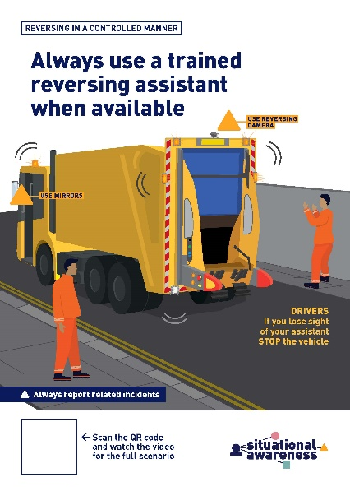
No job is so important we cannot take time and do it safely
- What is the purpose of a reversing assistant?
- When should you use a reversing assistant?
- If a driver loses sight of a reversing assistant, what should they do?
- How can you make my colleagues aware of the blind spots around the vehicle?
- Where are the most hazardous areas to reverse into and why?
- What do we refer to as the crush zone when reversing?
- When assisting a vehicle to reverse, name the hazards that might present themselves
- What are the signals to start and stop a reversing manoeuvre?

We look out for and trust each other
- If a colleague was to walk behind a reversing vehicle in an uncontrolled manner, what would you do?
- Would you report a colleague for not following the reversing procedure? Why if not?

We share and seek ideas for improvement
- Have you any suggestions or improvements to avoid or minimise reversing activities?

- Scan the QR code to access the digital campaign content

